

GEORGE WASHINGTON HIGH SCHOOL
MANGILAO, GUAM
US History – Visitation Extra Credit
cgombar@gmail.com

Organization Visited (please check one)

- T. Stell Newman Visitor Center
- Pacific War Museum
- CAHA Gallery
- UOG Isla Center For The Arts
- Guam Wildlife Refuge (Ritidian)

Please affix organization stamp/ seal
and date HERE.

Organization representative signature/ date

TIME IN:
TIME OUT:

Students must be present at organization for no less than 30 minutes. Students are expected to practice school/ classroom rules and policies regarding respect and acceptable behavior while present at visitation sites. Write a brief summary (no less than 3 full paragraphs) on the back of this form reflecting on your visit to the organization. What did you see? Was there anything that stood out for you? What did you enjoy most? What did you not enjoy? What was something new you learned about during the visit? Have a great time and enjoy your break.


GEORGE WASHINGTON HIGH SCHOOL
MANGILAO, GUAM
US History – Visitation Extra Credit
cgombar@gmail.com

Organization Visited (please check one)

- T. Stell Newman Visitor Center
- Pacific War Museum
- CAHA Gallery
- UOG Isla Center For The Arts
- Guam Wildlife Refuge (Ritidian)

Please affix organization stamp/ seal
and date HERE.

Organization representative signature/ date

TIME IN:
TIME OUT:

Students must be present at organization for no less than 30 minutes. Students are expected to practice school/ classroom rules and policies regarding respect and acceptable behavior while present at visitation sites. Write a brief summary (no less than 3 full paragraphs) on the back of this form reflecting on your visit to the organization. What did you see? Was there anything that stood out for you? What did you enjoy most? What did you not enjoy? What was something new you learned about during the visit? Have a great time and enjoy your break.
T. Stell Newman Visitor Center

We are located at the former Army Reserve Center in Sumay. We are at the southernmost end of Route 1, Marine Corps Drive near the Naval Station Guam front gate.

For more information and hours, please call (671) 333-4050.
Open from Sunday through Saturday, 9:00 a.m. to 4:30 p.m. We are closed Thanksgiving Day, Christmas Day, and New Year's Day.
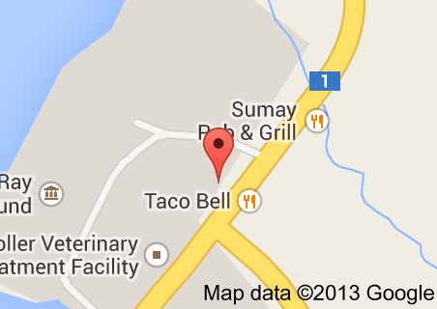

The Pacific War Museum

open 7 Days a week.
9am to 4pm

tel: (671) 477-8355
fax: (671) 472-6070

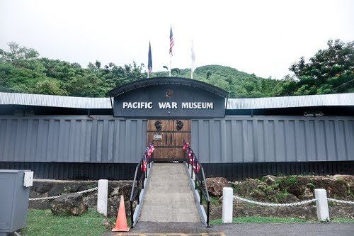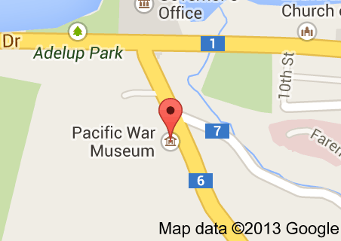

GUAM NATIONAL WILDLIFE REFUGE
RITIDIAN POINT

The Guam National Wildlife Refuge, Ritidian Unit and the Nature Center are open seven days a week (closed on federal holidays) from 8:30 am to 4 pm and admission is free. If people are interested in taking a tour of the forest and the caves, arrangements must be made in advance by calling (671) 355-5096.

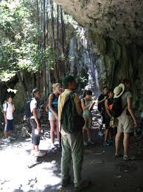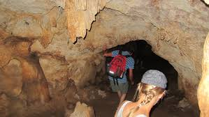

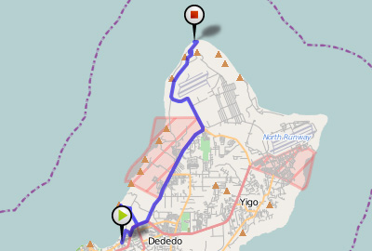

The ISLA Center is located at house No.15, Dean’s Circle on the campus of the University of Guam. ISLA’s hours are from 10:00 AM to 5:00 PM Monday through Friday, and from 10:00 AM to 2:00 PM on Saturday. Call ISLA at 735-2965 for more information about ISLA’s shows or to arrange for tours.



